**Theory Assignment**

**Assignment name**: Activity and Sequence Diagram of Atm

**Prepared by :-**

**MD. Mofijul islam**

**171442611**

**CSE (Eve)**

**City University**

**Prepared For :-**

**Supta Philip Richard**

**Lecturer of CSE Department**

**City University**

Activity Diagram

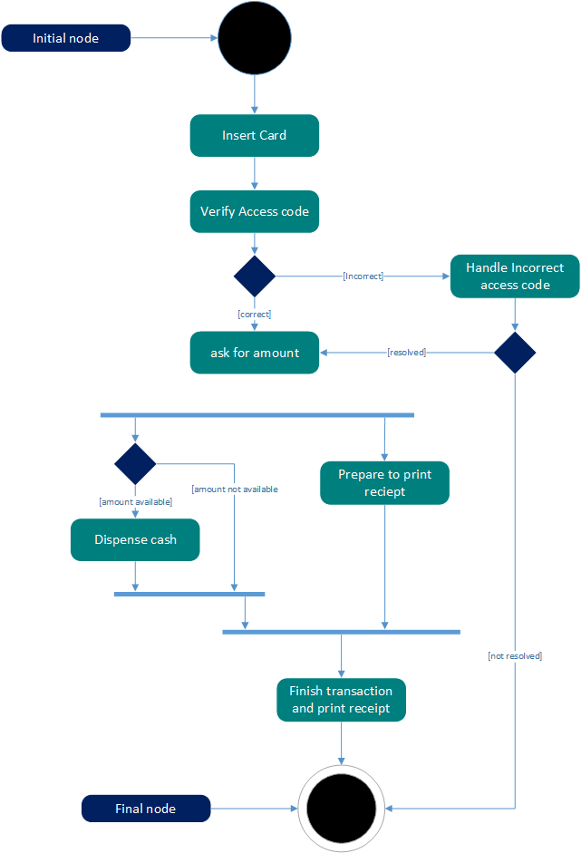

Sequence Diagram

